ADINA ISRAN
2303A52222
BATCH – 42

Collaborative AI Coding: Pair Programming and Version Control Integration

Task 1 – AI-Assisted Pair Programming
Example:
Use AI to generate an initial Expense Tracker Application.
• Ask AI to create a basic program to record daily expenses and
categories.
• Prompt AI to suggest improvements such as:
o Monthly expense summary
o Input validation
o Code refactoring into functions
• Compare the initial and improved versions to understand AI’s
role in collaborative coding.

Prompt: "Create a basic Python script to record daily expenses and categories. Then, refactor it into functions, add input validation to prevent negative amounts, and include a function that prints a monthly summary."

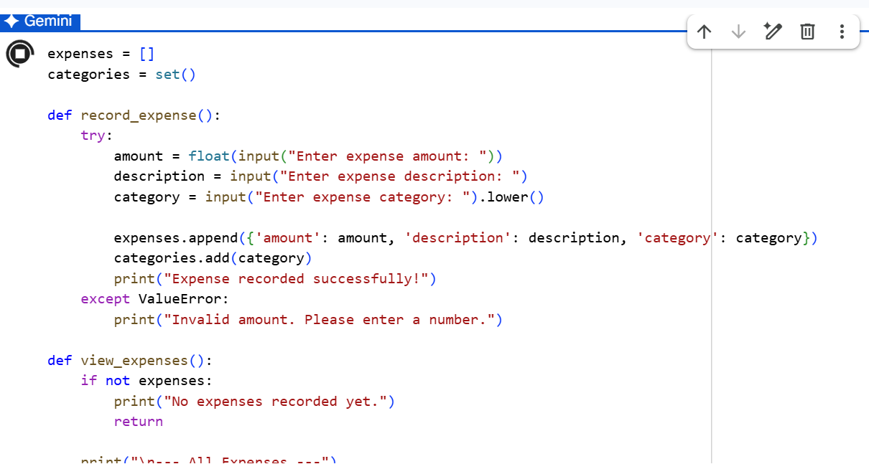
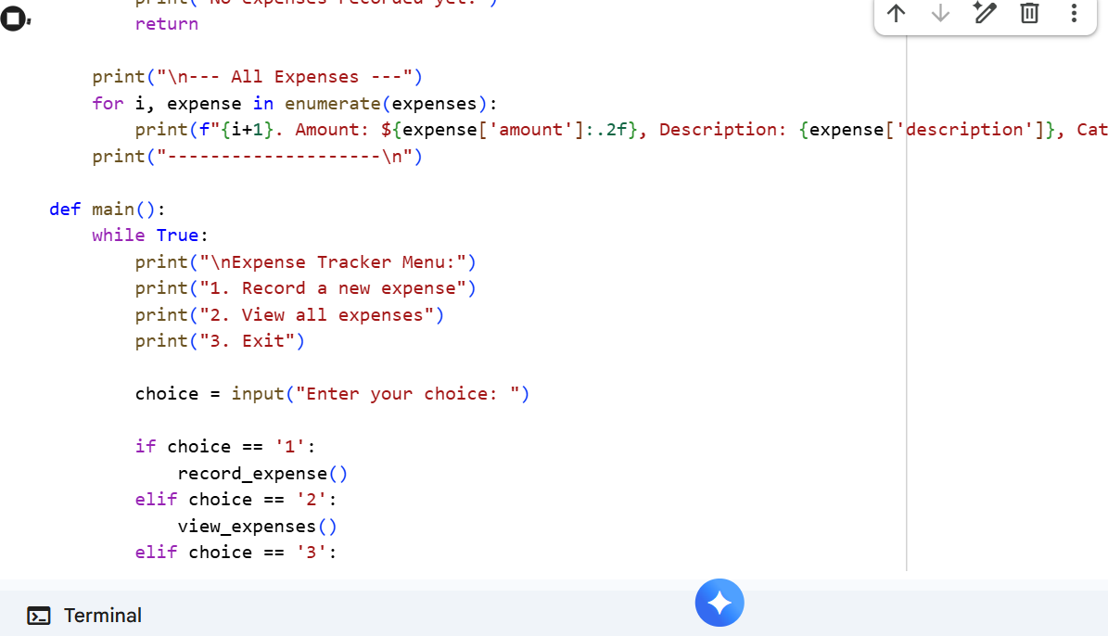
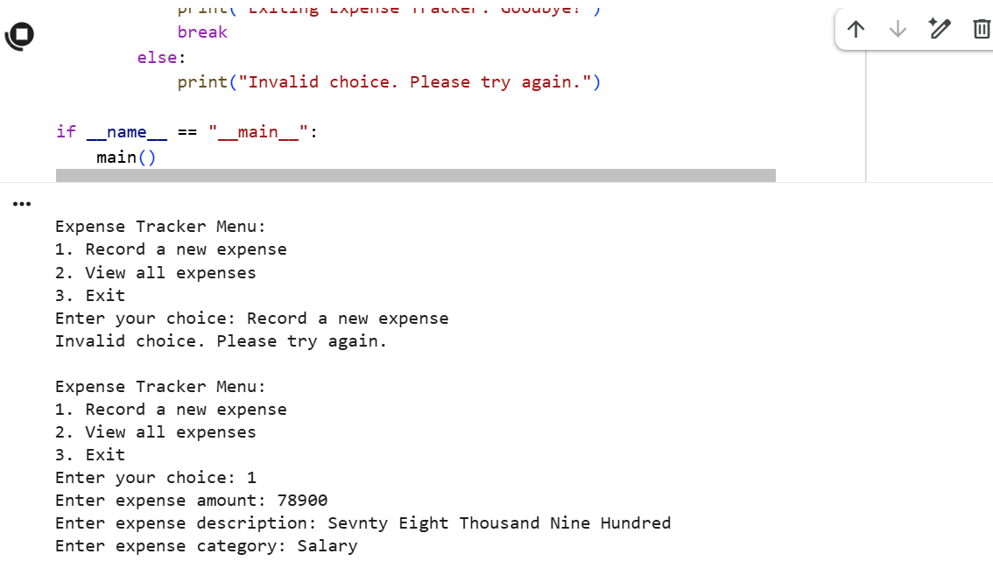
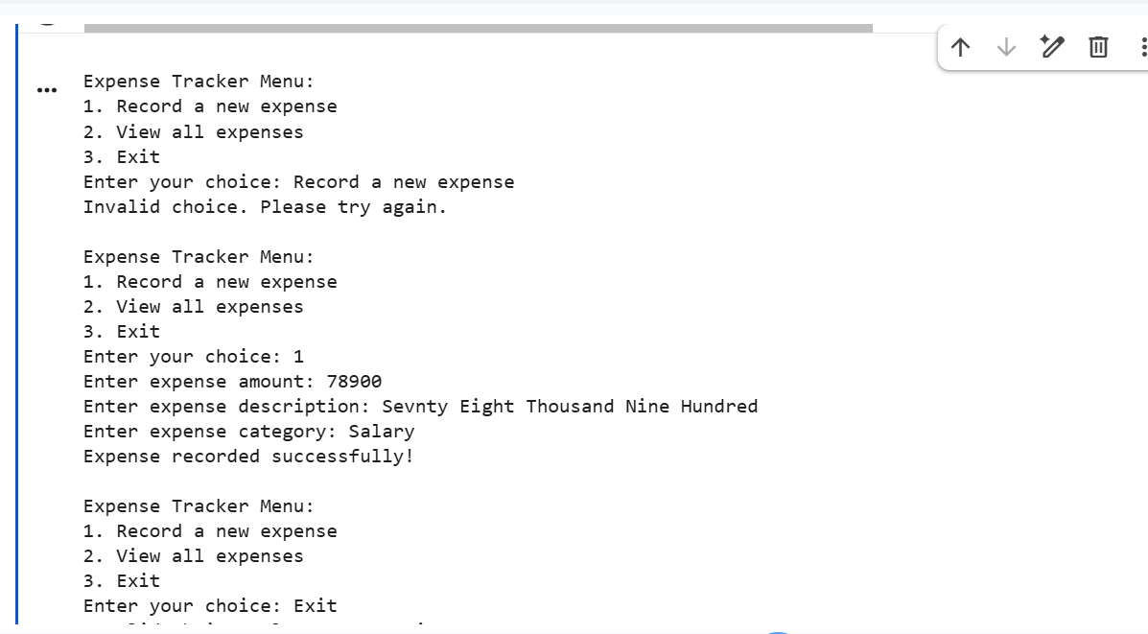
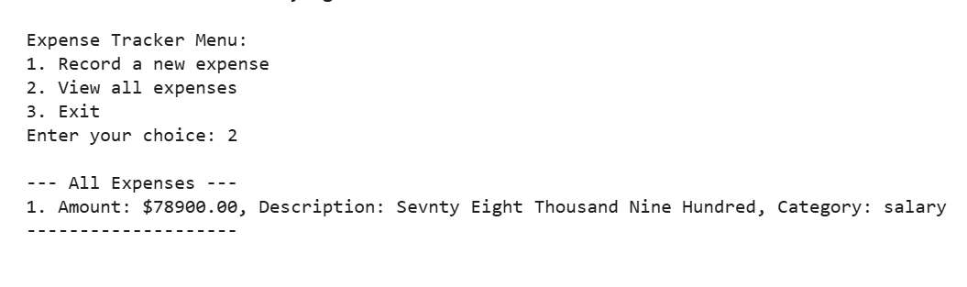

Justification: I started with a core script to establish the logic, then used AI to modularize the code. This shows how AI acts as a 'senior dev' by cleaning up structure and ensuring the app doesn't crash on bad user input.
Task 2 – Version Control Integration
Example:
Manage a Student Grade Calculator project using Git.
• Initialize a Git repository for the project.
• Create a new branch to add AI-assisted features such as:
o Grade classification (A, B, C, etc.)
o Average and percentage calculation
• Commit changes with meaningful commit messages.
• Merge the feature branch back into the main branch and resolve
conflicts if any.
Prompt: "I have a basic grade calculator; help me write a function that calculates the average and assigns a letter grade (A-F). Also, provide the Git commands to create a branch named feature-grading and merge it back."

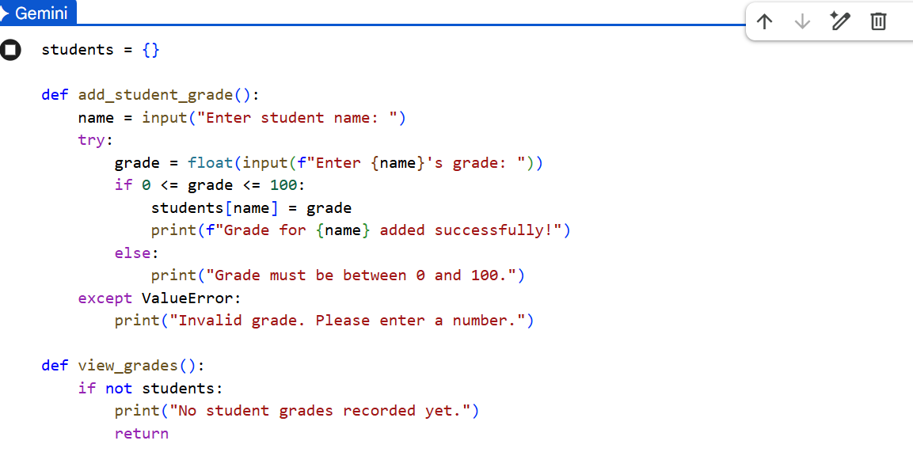
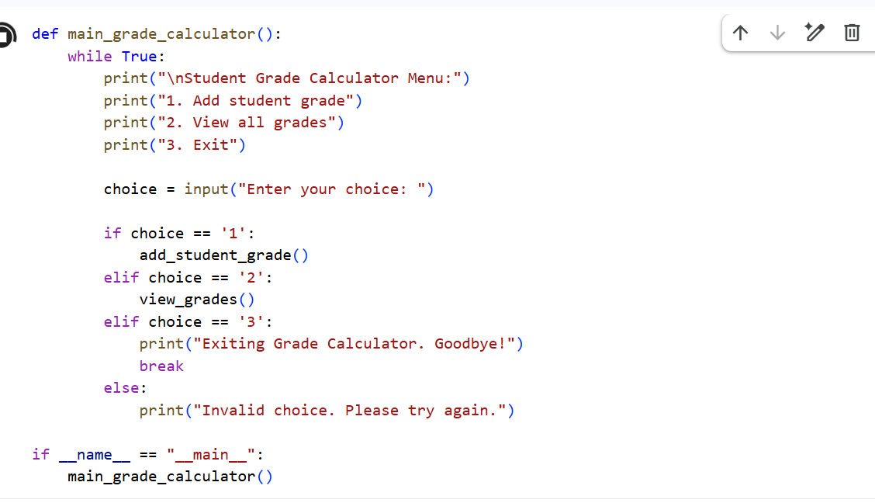
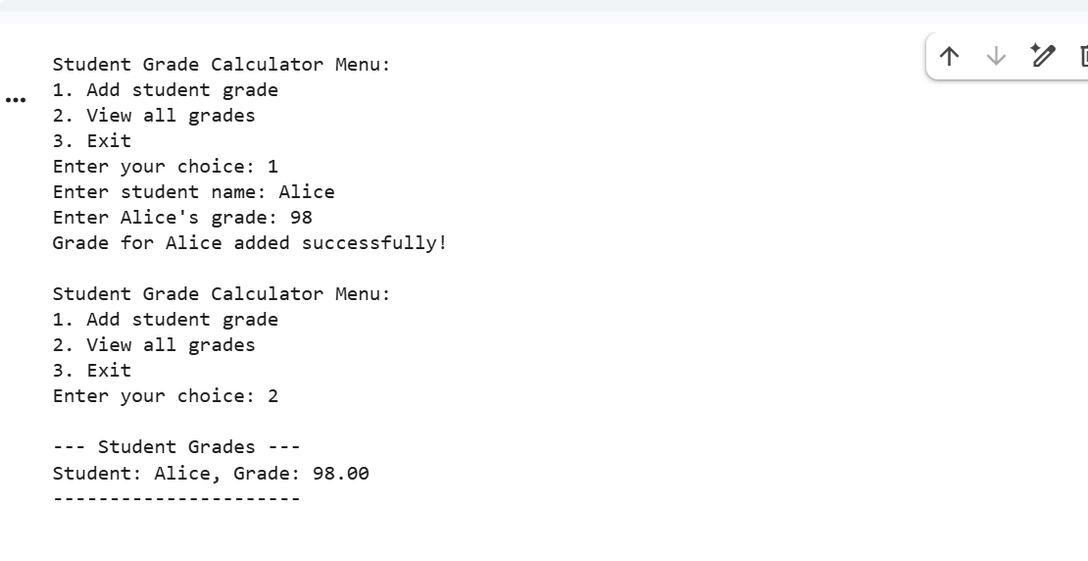

Justification: This approach uses AI to bridge the gap between "writing code" and "managing a project." It helps keep the main branch stable while we experiment with new logic in an isolated environment.

Task 3 – AI for Commit Message Generation
Example:
Use AI to generate commit messages for a Password Validation
Module.
• Modify the code to add rules like:
o Minimum length
o Special character requirement
• Ask AI to generate commit messages describing these updates.
• Compare AI-generated messages with human-written ones and
analyze clarity.

Prompt: "I just updated my password validator to require at least 8 characters and one special symbol. Based on these changes, write a professional, concise Git commit message following Conventional Commits standards."

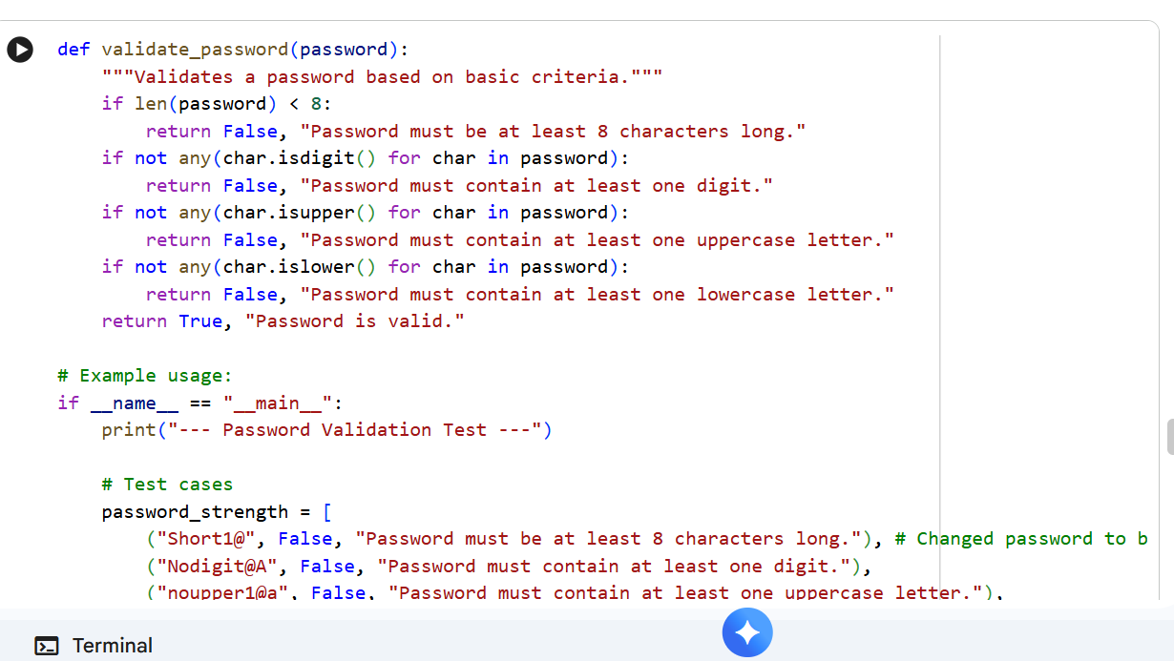
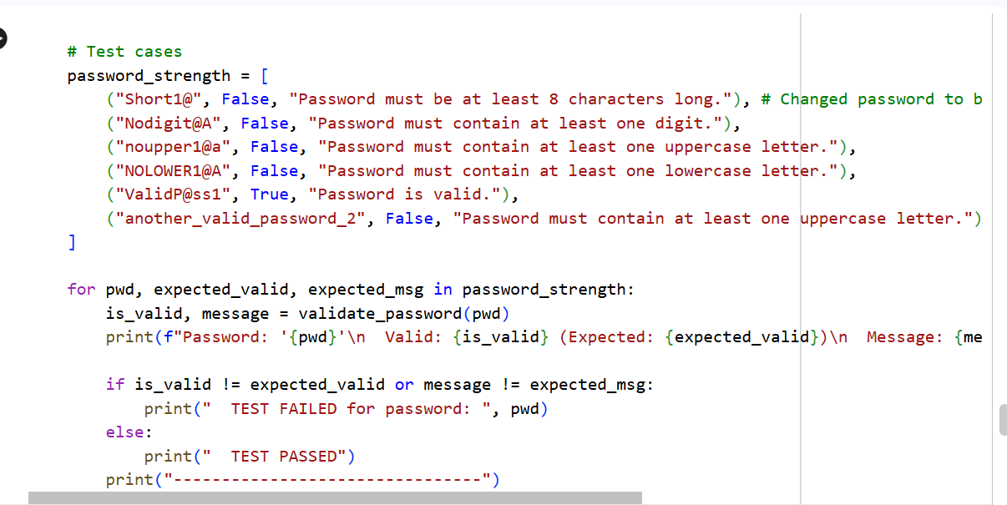
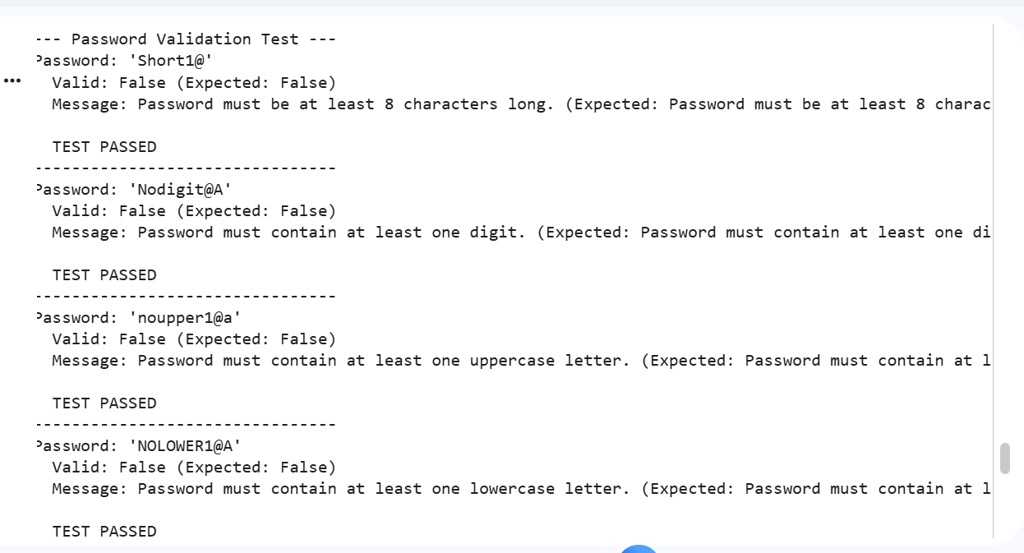

Justification: Human messages are often vague (like "fixed stuff"), but AI can instantly generate descriptive, standardized messages. This improves project documentation and makes it much easier for teammates to track history.

Task 4 – Pair Programming Simulation
Scenario:
Collaboratively develop a Quiz Management System.
• Student A creates the initial quiz program with questions and
answers.
• Student B, with AI assistance, adds features such as:
o Score calculation
o Input validation
• Both students collaborate using Git branching and merging to
integrate their changes.

Prompt: "Act as my pair programmer. I have a basic quiz list; please write a robust score-tracking system and a loop that validates if the user entered a valid option (A, B, or C) before proceeding."

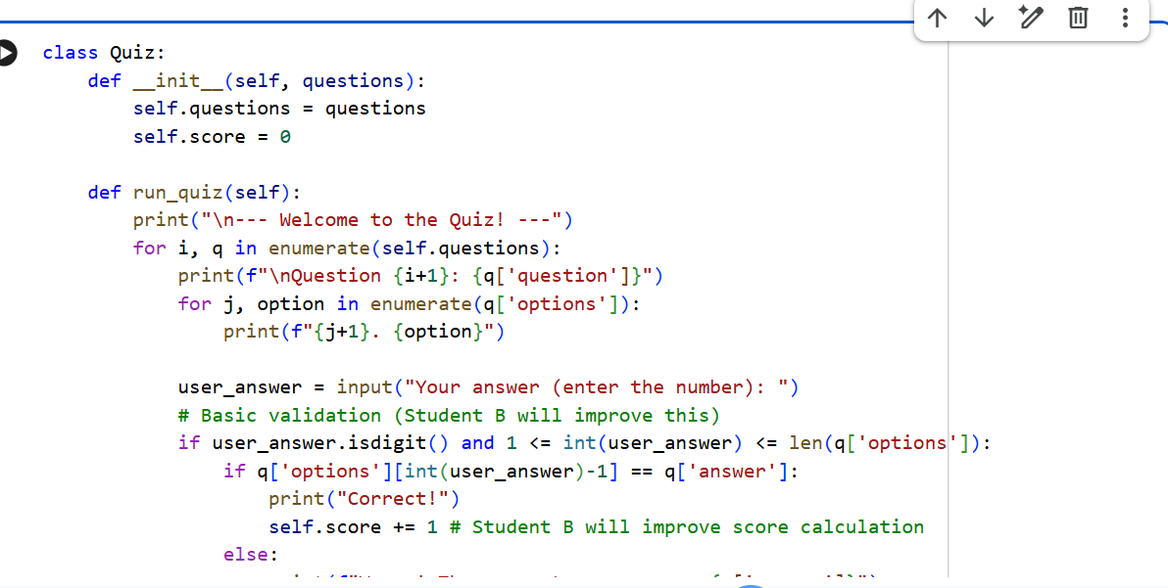
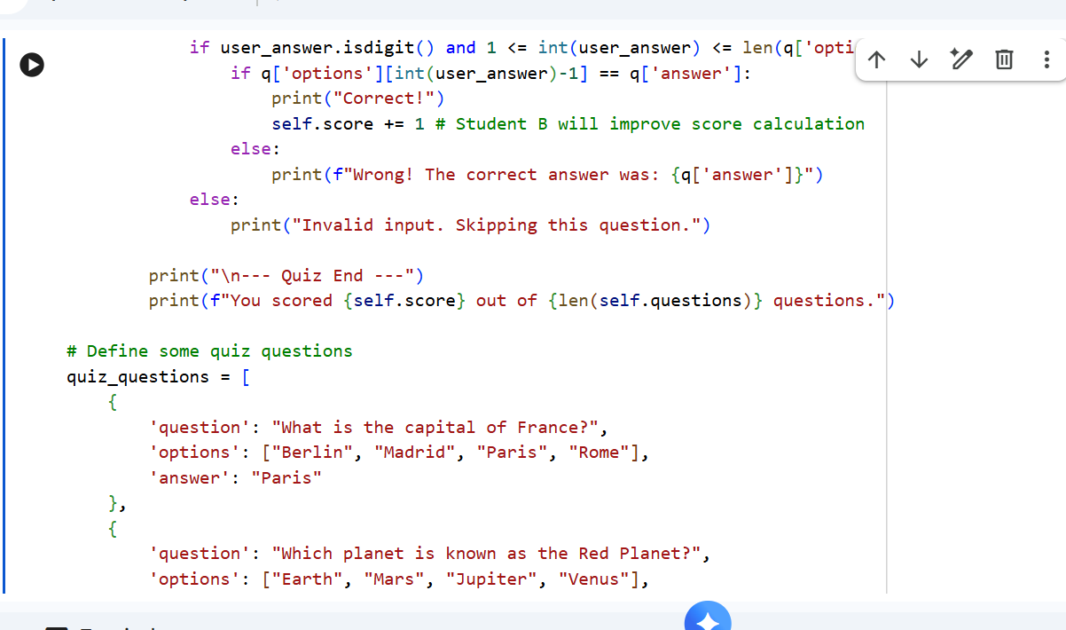
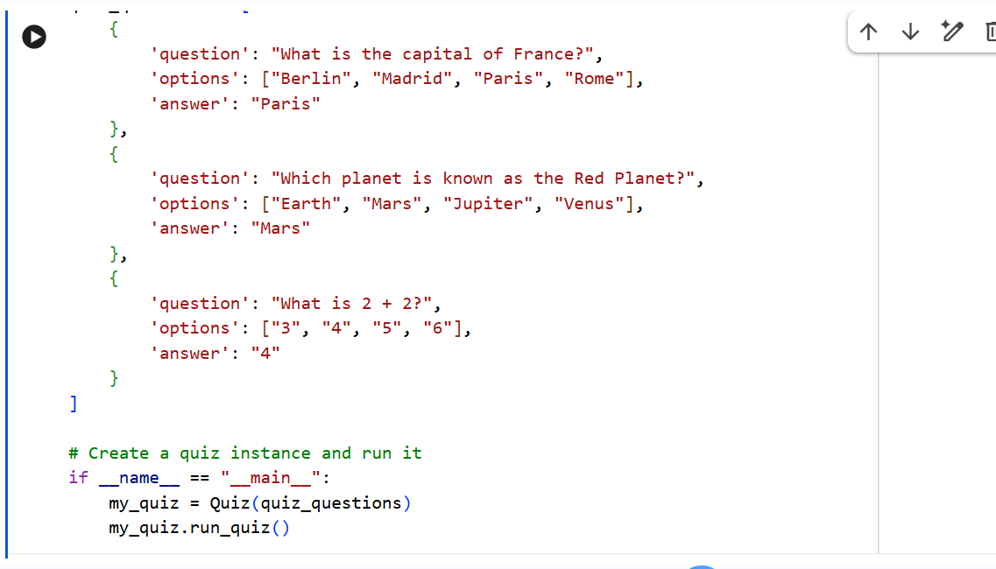
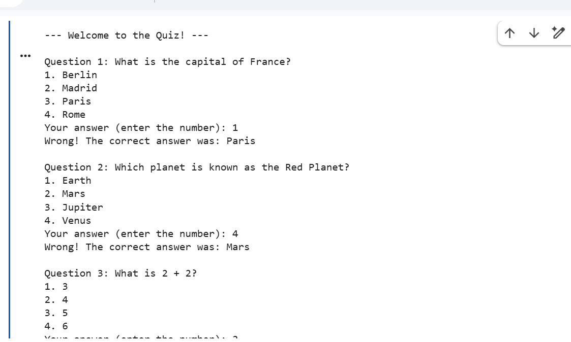
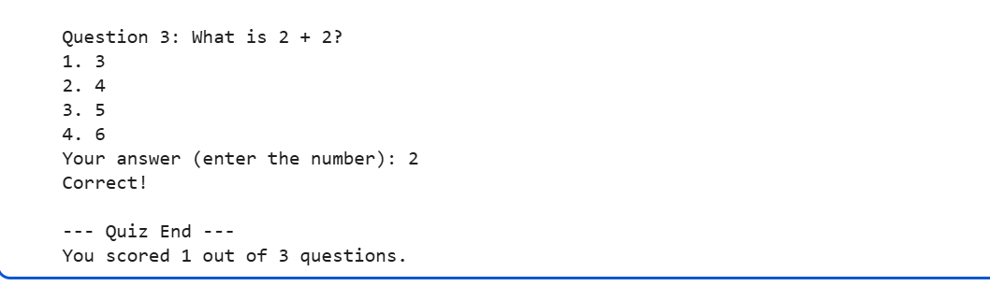

Justification:
This simulation highlights the 'driver-navigator' dynamic. While one student handles the core logic, the AI (assisting Student B) focuses on "defensive programming," ensuring the system is user-friendly and error-free.

